**Problem Statement**

Develop a web site for **online talk show**. The requirements are below

1. User can post a topic.

2. User can select a topic and post a comment

3. User can select a topic and view the latest comment posted for that topic.

4. User can search for topic

5. User can search for comment

**User Interfaces:**

Page 1 Input page

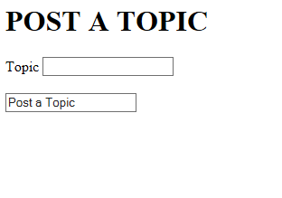

Page 2 output page

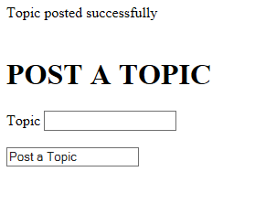

Page3 input page

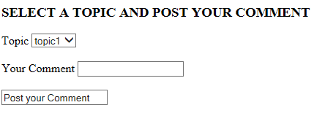

Page 4 output page

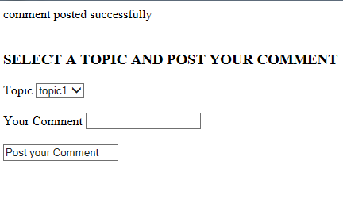

Page 5 input page

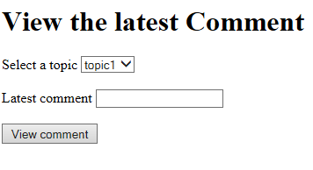

Page 6 output page

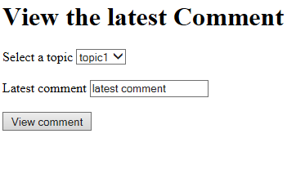

Page 7 Search page

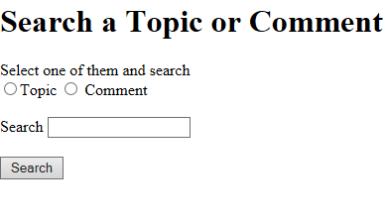

Page 8 search result page

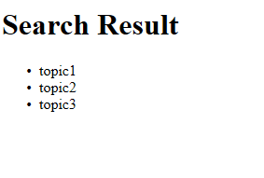

1. Post Topic:

* Create **postTopic.jsp** page for gathering topic description with the following text field Topic.
* Once the submit button is clicked, the doPost () method of **ToipcServlet** will be invoked, and from doPost () method call createTopic (TopicBean) method of **TopicDAO**. Form details to be passed to the method as a Bean.(TopicBean.java)
* createTopic (TopicBean) method of TopicDAO will insert the topic record in the table **TOPIC_<COMMITID>**

2. Post Comment:

* Create **postComment.jsp/ASP.NET** page for gathering comment for the selected topic .It has the fields drop down for topic selection, Comment text area field.
* Once the submit button is clicked, the doPost() method of **CommentServlet**  will be invoked and from doPost () method, call createComment(CommentBean,int toipcId) of **CommentDAO**. Form details to be passed to the method as a Bean.(CommentBean.java). Selected topic id shall be passed to the method along with CommentBean.
* createComment(CommentBean,toipcId) of **CommentDAO** will insert a comment record in table **COMMENT_<COMMITID>**
* While inserting a record, store system date in the column Comment_Date of

table **COMMENT_<COMMITID>**

3. View Comment

* Create **viewComment.jsp /ASP.NET** page for displaying latest comment for the selected topic. It will have the fields: drop down for selecting topic, text area for viewing comment and a button for viewing comment.
* Once the viewComment button is clicked, doGet () method of **CommentServlet** will be invoked and inside the doGet () method, call getLatestComment(int topicId) method of **CommentDAO**.
* getLatestComment(int topicId) method of CommentDAO will retrieve the latest comment for the selected topic Id from table **COMMENT_<COMMITID>**

4. Search Topic/Comment

* Create **search.jsp**/ASP.NET page for searching a topic or comment. It will have the following fields: Search text field, Radio button for choosing topic or comment, a Search button and search results.
* Once the search button is clicked, doGet () method of **SearchServlet** will be invoked and inside doGet () method, either call getTopicList (String searchString ) of TopicDAO or getCommentList(String searchString) of CommentDAO based on selected radio button(topic or comment) value.
* getTopicList (String searchString ) of TopicDAO will fetch the matched topics from the table **TOPIC_<COMMITID>**
* getCommentList (String searchString) of CommentDAO will fetch the matched comments from the table **COMMENT_<COMMITID>**

**Java script validation:**

Please perform following validations for all the pages

1. All fields are mandatory

2. Special characters are not allowed.

Display appropriate alert messages for the above requirements.

**Table decription**

1. **TOPIC_<COMMITID>**

Columns:

TOPIC_ID NUMBER PRIMARY KEY

TOPIC_DESC VARCHAR (150)

2. **COMMENT_<COMMITID>**

Columns:

COMMENT_ID NUMBER PRIMAY KEY

COMMENT_DESC VARCHAR (250)

COMMENT_DATE DATE

TOPIC_ID NUMBER FOREIGN KEY

**Data Base URL**

"jdbc:oracle:thin:@10.232.71.29:1521:INATP02","shobana","shobana"

Note: MS SQL shall be used for DOT NET.